Welcome to our Red Dragon Portal guide

This document will show you how to easily navigate and become a member of the Red Dragon Portal

This guide includes:

Registration

Enrolments

Change Of Classes

Invoices

Payments

**Registration**

Start by clicking on the link posted here: [**Red Dragon Portal**](https://nam01.safelinks.protection.outlook.com/?url=http%3A%2F%2Furl9130.app.classmanager.com%2Fls%2Fclick%3Fupn%3Dg2EaNxESDskBjQb7nOvIC-2Byzt0Oob7vHEmWZB40Hld5HPZJEbCfM-2BpBrEnl-2BA5IaVQt-2BwrGTs1dvaMmrVIZdz03s7iXP-2BA-2FovIJjCQ2AuPbJNN2Df5BtPPQoV8Cr-2B5wwI18vWO48pGegJHLQlsnJtFs7kEx0xCu8oo6o9MEZKFTMYMl5fgfUhcQyzPsqhqNCRekl_pvG00d53y5LS9aIBhnua1SrNzQxJkr5y3hcmtLkHazhoBn9aUEIoSdX7QOEyDqwsVvceg7nYV8FiqfNc8QDx3lLWXcXnjBK3tn9Rf-2Bigp7eypM1ToKONlViKlGCaiY4f9oNtar30RNqWuAPD5tynugjB1PVfJ-2BPWs7qeT-2Bc17WNWxcN4-2BoBDy8Q8anxL0z-2BE7vHU1tkwk92awbFjE6orJ1MUAsWeDp7om9dBUmoV70Pj66O1oo3i8vdaWTbJhf5I91O3dSUTPQ5-2BrswIGfm4-2FvsRcRCBWq3VGTG22hZOsIfTbAkXXKJ0MsmJ32gVvN88&data=02%7C01%7C%7C6592cdaa8a9e48c0a31208d82de2d707%7C84df9e7fe9f640afb435aaaaaaaaaaaa%7C1%7C0%7C637309799573508454&sdata=dipXe6g3rFV3N1HhecRtjy34q1wsTMPTNNr4Bj1Qsks%3D&reserved=0)

Once you click on the link you will be greeted with the following screen where you will register.

On this screen you will enter all your details and your child’s details. Once you are done click on register. Following this step, you will be taken back into the login screen where you may use your new login details.

Once logged in you will be taken to the home dashboard screen where you can see a variety of different options to choose from such as: Enrolment to classes, Upcoming classes, Noticeboard, Invoices & Payments (See picture below)

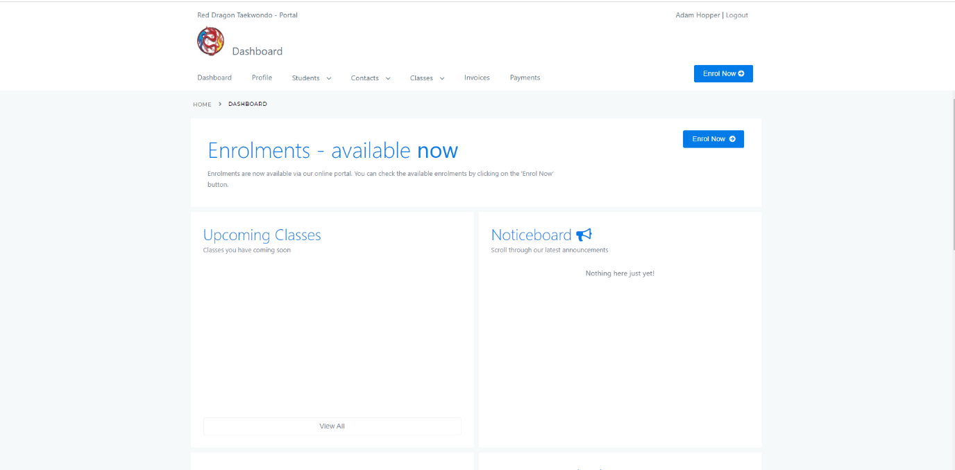

**Enrolments**

To start enrolment of your child click enrol now in the top right. Here you will select which child you choose to enrol and which classes are available to you.

If you have already previously registered for classes and wish to see what upcoming classes you have, you ca access this by going to classes from the dashboard menu and see upcoming classes.

Note: Enrolments are done in seasons, for example season 1 will be term 1. The same goes for seasons 2, 3 and 4

**Change of classes**

If you wish to change the class you are taking part in all you need to do is contact Master John and let him know so he can de register you from your current class and register you for another providing there is space available

**Invoices**

Once you have enrolled your child you will be sent an invoice from Master John which can be seen in the invoices tab of your dashboard after he has confirmed it. Invoices can be payed with a variety of different methods

**Payments**

Various methods of payments can be made

These methods include

Cash

Bank Transfer

Paypal

Webstore

Credit Card

For your preferred payment method please refer to the invoice on how to make that payment

Once payment has been made and accepted by Master John you will see on your dashboard of the portal you have no outstanding balances and you have completed your enrolment

If you have any questions or concerns please fell free to contact Master John

0419 165 416

Jtsoutis@gmail.com